

**Food Waste Management Application**

High Level Design & Low Level Design

**Document Control :**

|  |  |  |  |  |  |  |  |  |
| --- | --- | --- | --- | --- | --- | --- | --- | --- |
| **Food Waste Management Application** | | | | | | | | |
| Guided by-  **Mr. Sankar** |  |  | |  |  |  |  |  |
| **Date** | **Version** | **Author** | **Brief Description of Changes** | | | | **Approver Signature** | |
| December 07 2022 | 1.0 | A. Soumi Narayani  Nossam Navaneetha  Navitha Juturu  Maddireddi Pravallika  Rajmoni Shirisha |  | | | |  | |

**INDEX**

1. Introduction ------------------------------------------------ 4

1.1 Intended audience ------------------------------------------------ 4

1.2 Project purpose ------------------------------------------------ 4

1.3 Key project objective ------------------------------------------------ 4

1.4 Project scope ------------------------------------------------ 4

2. Design overview ------------------------------------------------ 4

2.1 Design objectives ------------------------------------------------ 8

2.2 Error Detection / Exceptional Handling -------------------------------------------- 8

2.3 Performance ------------------------------------------------ 8

2.4 Maintenance ------------------------------------------------8

3. System architecture ------------------------------------------------ 9

3.1 NGO ------------------------------------------------9

3.2 Hotel -----------------------------------------------9

3.3 Admin -----------------------------------------------10

3.3.1 NGO Record maintenance ------------------------------------------------10

3.3.2 Hotel Record Maintenance ------------------------------------------------10

3.4 Food Request -----------------------------------------------10

3.4.1 NGO Request -----------------------------------------------10

3.4.2 Food Request ----------------------------------------------11

3.4.3 File Handling ---------------------------------------------11

4. Detailed system design -----------------------------------------------12

4.1 Flowchart of main application ----------------------------------------------12

4.2 DFD Level 0 Diagram ------------------------------------------------13

4.4 DFD Level 1 Diagram ----------------------------------------------13

5. Tools Report ---------------------------------------------14

5.1 Splint Report ----------------------------------------------14

5.2 Valgrind Report ------------------------------------------15

6. Testing

6.1 Unit Testing ----------------------------------------------16

6.2 Integration Testing —-------------------------------------------17

7. Environmental Description -----------------------------------------------18

# 1: Introduction

The purpose of this project is to show the requirements for the Food Waste Management application, in which either NGO request the hotel/restaurant or the hotel/restaurant requests the NGO for the left-over food which is to be supplied for the needy.

**1.1 Intended Audience:**

This document is intended to be read by, NGO and hotel/restaurant and admin.

**1.2 Project Purpose:**

The purpose of this project is to show the requirements for the Food Waste Management application, in which either NGO request the hotel/restaurant or the hotel/restaurant requests the NGO for the left-over food which is to be supplied for the needy.

**1.3 Key Project Objectives:**

1. Allows NGO and hotel/restaurant to register.
2. NGO’s requests hotels/restaurants.
3. Hotels/Restaurants requests NGO’s.
4. File Maintenance by admin.
5. Admin check and reports the data.

**1.4 Project Scope:**

This project aims to create the development of food waste management application. This reduces restaurant food wastage by giving left-over food to NGO’s. NGO’s will raise a request, in case of any left-over food restaurants have. This request is sent to the restaurant manager of that particular restaurant. The NGO Manager then approves the request and assigns it to one of the NGO employees for takeaway and forwards the request to the restaurant. The left-over food at the restaurant can be given to NGO’s at the end of the day. The admin can track the history of restaurants and NGO’s for the left-over food.

**2. Design Overview:**

Food Waste Management comprises of the following modules:

|  |  |
| --- | --- |
| Name of the Module | NGO Registration |
| Handled by | Rajmoni Shirisha |
| Description | This feature allows the NGO to add a new record. It asks for the NGO registration id, name of NGO, number of beneficiaries, established year, office address and the telephone number |

|  |  |
| --- | --- |
| Name of the Module | NGO edit |
| Handled by | Rajmoni Shirisha |
| Description | This feature allows the NGO to edit basic details. |

|  |  |
| --- | --- |
| Name of the Module | NGO View |
| Handled by | Rajmoni Shirisha |
| Description | This feature displays the details of NGO. |

|  |  |
| --- | --- |
| Name of the Module | NGO Request |
| Handled by | Maddireddi Pravallika |
| Description | This feature allows the NGO to request the left-over food from the hotel / restaurant. If the request is accepted by the hotel / restaurant the conformation slip is generated. If not the request will be forwarded to admin. |

|  |  |
| --- | --- |
| Name of the Module | Hotel Registration |
| Handled by | Nossam Navaneetha |
| Description | This feature allows the hotel to add the hotel/restaurant record. It asks for the hotel/restaurant registration id, name,  address and contact details. |

|  |  |
| --- | --- |
| Name of the Module | Hotel Edit |
| Handled by | Nossam Navaneetha |
| Description | This feature allows the hotel to edit the basic details. |

|  |  |
| --- | --- |
| Name of the Module | Hotel Request |
| Handled by | Maddireddi Pravallika |
| Description | This feature allows the hotel to request NGO’s to collectthe left-over food. |

|  |  |
| --- | --- |
| Name of the Module | Yes |
| Handled by | Maddireddi Pravallika |
| Description | This feature gives confirmation regarding Hotel is ready to supply food. |

|  |  |
| --- | --- |
| Name of the Module | No |
| Handled by | Maddireddi Pravallika |
| Description | This feature gives confirmation that Hotel cannot supply food.So choose alternative hotel. |

|  |  |
| --- | --- |
| Name of the Module | Hotel view |
| Handled by | Nossam Navaneetha |
| Description | This feature displays the details of hotel / restaurants. |

|  |  |
| --- | --- |
| Name of the Module | NGO Add |
| Handled by | A. Soumi Narayani |
| Description | This feature adds a new NGO record to  the file by admin. It asks for the NGO registration id, name of NGO, number of  beneficiaries, established year, office address and the telephone number. |

|  |  |
| --- | --- |
| Name of the Module | NGO Edit |
| Handled by | A. Soumi Narayani |
| Description | This feature edits the NGO’s record by admin,  based on the registration id of the NGO’s, it help to modify the details such as number of beneficiaries, name, office address and the telephone number. |

|  |  |
| --- | --- |
| Name of the Module | NGO Delete |
| Handled by | A. Soumi Narayani |
| Description | This feature deletes the details of NGO  based on registration id. |

|  |  |
| --- | --- |
| Name of the Module | NGO View |
| Handled by | A. Soumi Narayani |
| Description | This feature displays the details of NGO. |

|  |  |
| --- | --- |
| Name of the Module | Hotel Add |
| Handled by | Navitha Juturu |
| Description | This feature adds the new hotel/restaurant record to the file by admin. It asks for the hotel/restaurant registration id, name, address and contact details. |

|  |  |
| --- | --- |
| Name of the Module | Hotel Edit |
| Handled by | Navitha Juturu |
| Description | This feature edits the details of the hotel/  restaurants like address, name, contact details by admin. |

|  |  |
| --- | --- |
| Name of the Module | Hotel Delete |
| Handled by | Navitha Juturu |
| Description | This feature deletes the details of hotel/  restaurants based on registration id. |

|  |  |
| --- | --- |
| Name of the Module | Hotel View |
| Handled by | Navitha Juturu |
| Description | This feature displays the details of hotel/ restaurants. |

|  |  |
| --- | --- |
| Name of the Module | Admin Check |
| Handled by | Maddireddi Pravallika |
| Description | This feature checks for the requests made for a  particular day by an NGO and if the requested hotel can’t provide the food for that NGO  then he can assign an alternative hotel/ restaurants to the NGO. |

|  |  |
| --- | --- |
| Name of the Module | Admin Report |
| Handled by | Maddireddi Pravallika |
| Description | This feature will give a report on the number  of requests for a day and display it. Also gives  the name of the hotel / restaurants which got  maximum requests. |

|  |  |
| --- | --- |
| Name of the Module | NGO to list |
| Handled by | Maddireddi Pravallika |
| Description | This feature allows to write NGO records to the list. |

|  |  |
| --- | --- |
| Name of the Module | List to NGO |
| Handled by | Maddireddi Pravallika |
| Description | This feature allows to write NGO records to the list. |

|  |  |
| --- | --- |
| Name of the Module | Hotel to list |
| Handled by | Maddireddi Pravallika |
| Description | This feature allows to write Hotel records to the  list. |

|  |  |
| --- | --- |
| Name of the Module | List to Hotel |
| Handled by | Maddireddi Pravallika |
| Description | This feature allows to write Hotel records to the  list. |

**2.1 Design Objectives:**

Food Waste Management Application communicates among NGO’s, Hotels and admin for the supply of left-over food to the needy.

This reduces restaurant food wastage by giving leftover food to NGO’s. NGO’s will raise a request, in case of any leftover food restaurants have. This request is sent to the restaurant manager of that particular restaurant. The NGO Manager then approves the request and assigns it to one of the NGO employees for takeaway and forwards the request to the restaurant. The leftover food at the restaurant can be given to NGO’s at the end of the day. The admin can track the history of restaurants and NGO’s for the leftover food.

**2.2 Error Detection / Exceptional Handling:**

If the NGO’s or the Hotels wants to register with the existed user ID then it displays “User already Exists”. If the NGO’s or Hotels wants to add or edit the details of each other it displays “Permission Denied”.

**2.3 Performance:**

The system will work on the admin terminal. The performance depends on the hardware component of the admin’s system.

**2.4 Maintenance:**

Very little maintenance should be required for this setup. An initial configuration will be the only system required interaction after system is put together. The only other user maintenance would be any changes to settings after setup, and any specified special cases where user settings or history need to be changed. Physical maintenance on the system’s parts may be required, and would result in temporary loss of data or Internet. Upgrades of hardware and software should have little effect on this project but may result in downtime.

**3. SYSTEM ARCHITECTURE: -**

**3.1 NGO:**

**3.1.1 : NGO Registration:** This feature allows to add a new NGO record. I asks for the NGO registration id, name of NGO, number of beneficiaries,established year, office address and the telephone number.

**3.1.2 : NGO_Edit:** This feature allows the NGO to edit basicdetails.

**3.1.3NGO_View:** This feature displays the details of NGO.

## 3.2 Hotel:

**3.2.1 :Hotel_Registration**: This feature allows to add the new Hotel restaurant record . It asks for the hotel / restaurant registration id, name, address and contact details.

**3.2.2 :Hotel_Edit:** This feature allows the hotel / restaurant to edit the basic datails.

**3.2.3 :Hotel_View:** This feature displays the details of hotel / restaurants.

## 3.3 Admin:

* + 1. **NGO_Record_Maintenance:**

**3.3.1.1 : Admin_NGO_ADD:** This feature adds a new NGO record to the file by admin. It asks for the NGO registration id, name of NGO, number of beneficiaries, established year, office address and the telephone number.

**3.3.1.2 : Admin_NGO_Edit:** This feature edits the NGO’s record by admin based on the registration id of the NGO’s, it help to modify the details such as number of beneficiaries, name, office address and the telephone number.

**3.3.1.3:Admin_NGO_View:** This feature displays the details of NGO.

**3.3.1.4:Admin_NGO_Delete:** This feature deletes the details of NGO based on registration id.

## Hotel_Record_Maintenance:

## 3.3.2.1:Admin_Hotel_ADD: This feature adds the new Hotel/ restaurant record to the file by admin. It asks for the hotel / restaurant registration id, Name, address and contact details.

**3.3.2.2:Admin_Hotel_Edit:** This feature edits the details of the hotel/ restaurants like address, name, contact details by admin.

**3.3.2.3:Admin_Hotel_View:** This feature displays the details of hotel / restaurants.

**3.3.2.4:Admin_Hotel_Delete**: This feature deletes the details of hotel/restaurants based on registration id.

**3.3.2.5:Admin_Report:** This feature will give a report on the number of requests for a day and display it. Also gives the name of the hotel / restaurants which got maximum requests.

**3.3.2.6:Admin_Check:** This feature calls the NGO request function if the requested hotel can’t provide the food for that NGO.

**3.4 : Food Request:**

**3.4.1 : NGO_Request:** This feature allows the NGO to request the left-over food from hotel / restaurant. If the request is accepted by the hotel /restaurant the confirmation slip is generated. If not the request will be forwarded to admin.

**3.4.2 : Hotel_Request:** This feature allows the hotel to request the NGO to collect the left-over food.

**3.4.3:Yes:** This feature gives confirmation regarding Hotel is ready to

supply food.

**3.4.4:No:** This feature gives confirmation that Hotel cannot supply food.

So choose alternative hotel.

* + 1. **:File Handling:**

**3.4.3.1 :NGO File Handling:**

**3.4.3.1.1:NGO_to _list:** This feature allows to write NGO records to the list.

**3.4.3.1.2:list_to_NGO:** This feature allows to read NGO records from the list.

* + - 1. **:Hotel File Handling:**

**3.4.3.2.1:Hotel_to_list:** This feature allows to write Hotel records to the list.

**3.4.3.2.2:list_to_Hotel:** This feature allows to read Hotel records from the list.

**4. Detailed System Design**

4.1Flow chart of the application

**4.2 DFD LEVEL 1 DIAGRAM**

4.3 **DFD LEVEL 1 DIAGRAM**

**5 : Tools Report**

**5 .1 :Splint Tool Report**

fwm_func.c: (in function NGO_Registration)  
fwm_func.c:32:23: Function returns with non-null global new_n referencing null  
                     storage  
  A global variable does not satisfy its annotations when control is  
  transferred. (Use -globstate to inhibit warning)  
   fwm_func.c:29:12: Storage new_n may become null  
fwm_func.c:34:8: Test expression for while not boolean, type int: 1  
  Test expression type is not boolean or int. (Use -predboolint to inhibit  
  warning)  
fwm_func.c:40:3: Return value (type int) ignored: scanf("%s", chec...  
  Result returned by function call is not used. If this is intended, can cast  
  result to (void) to eliminate message. (Use -retvalint to inhibit warning)  
fwm_func.c:59:37: Only storage ptr_n->next_n assigned to unqualified (in post  
                     loop increment): ptr_n = ptr_n->next_n  
  The only reference to this storage is transferred to another reference (e.g.,  
  by returning it) that does not have the only annotation. This may lead to a  
  memory leak, since the new reference is not necessarily released. (Use  
  -onlytrans to inhibit warning)  
fwm_func.c:76:3: Unreachable code: break  
  This code will never be reached on any possible execution. (Use -unreachable  
  to inhibit warning)  
fwm_func.c:79:8: Test expression for while not boolean, type int: 1  
fwm_func.c:83:3: Return value (type int) ignored: scanf("%s", new_...  
fwm_func.c:84:14: Variable length initialized to type size_t, expects int:  
                     strlen(new_n->name)  
  To allow arbitrary integral types to match any integral type, use  
  +matchanyintegral.  
fwm_func.c:96:10: Parse Error. (For help on parse errors, see splint -help  
                     parseerrors.)

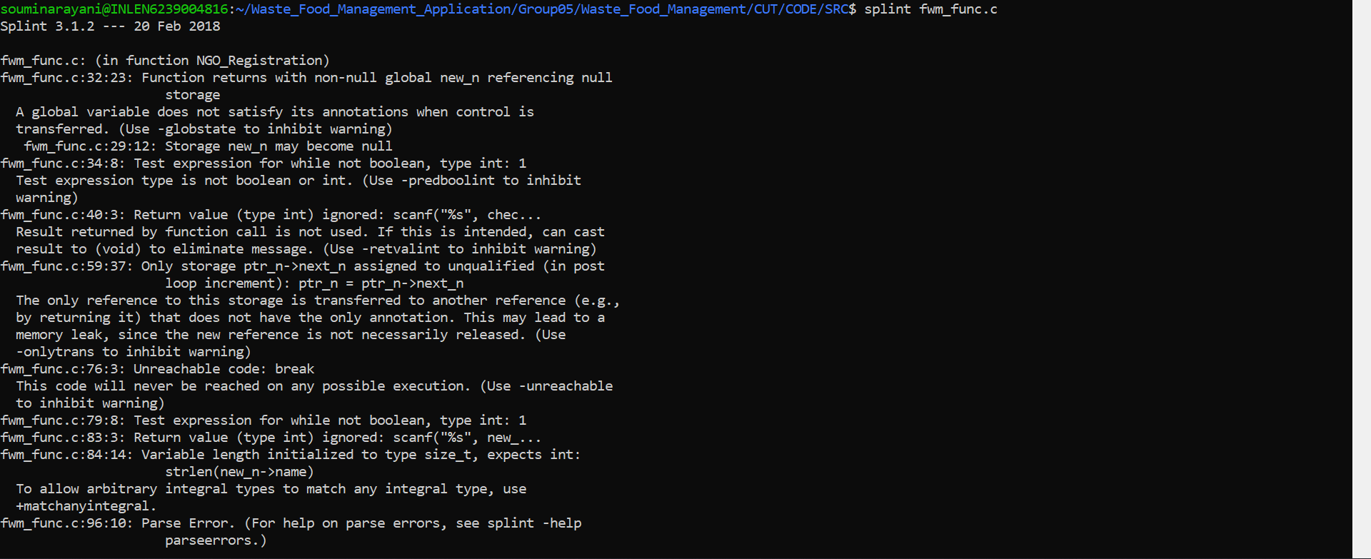

* 1. **Valgrind Tool Report:**

==1567== Memcheck, a memory error detector  
==1567== Copyright (C) 2002-2017, and GNU GPL'd, by Julian Seward et al.  
==1567== Using Valgrind-3.15.0 and LibVEX; rerun with -h for copyright info  
==1567== Command: ./fwm  
==1567==

..............MENU..............

1.NGO  
2.Hotel  
3.Admin  
4.Food request  
5.Exit

Enter your choice: 5  
==1567==  
==1567== HEAP SUMMARY:  
==1567==     in use at exit: 0 bytes in 0 blocks  
==1567==   total heap usage: 6 allocs, 6 frees, 3,936 bytes allocated  
==1567==  
==1567== All heap blocks were freed -- no leaks are possible  
==1567==  
==1567== For lists of detected and suppressed errors, rerun with: -s  
==1567== ERROR SUMMARY: 0 errors from 0 contexts (suppressed: 0 from 0)

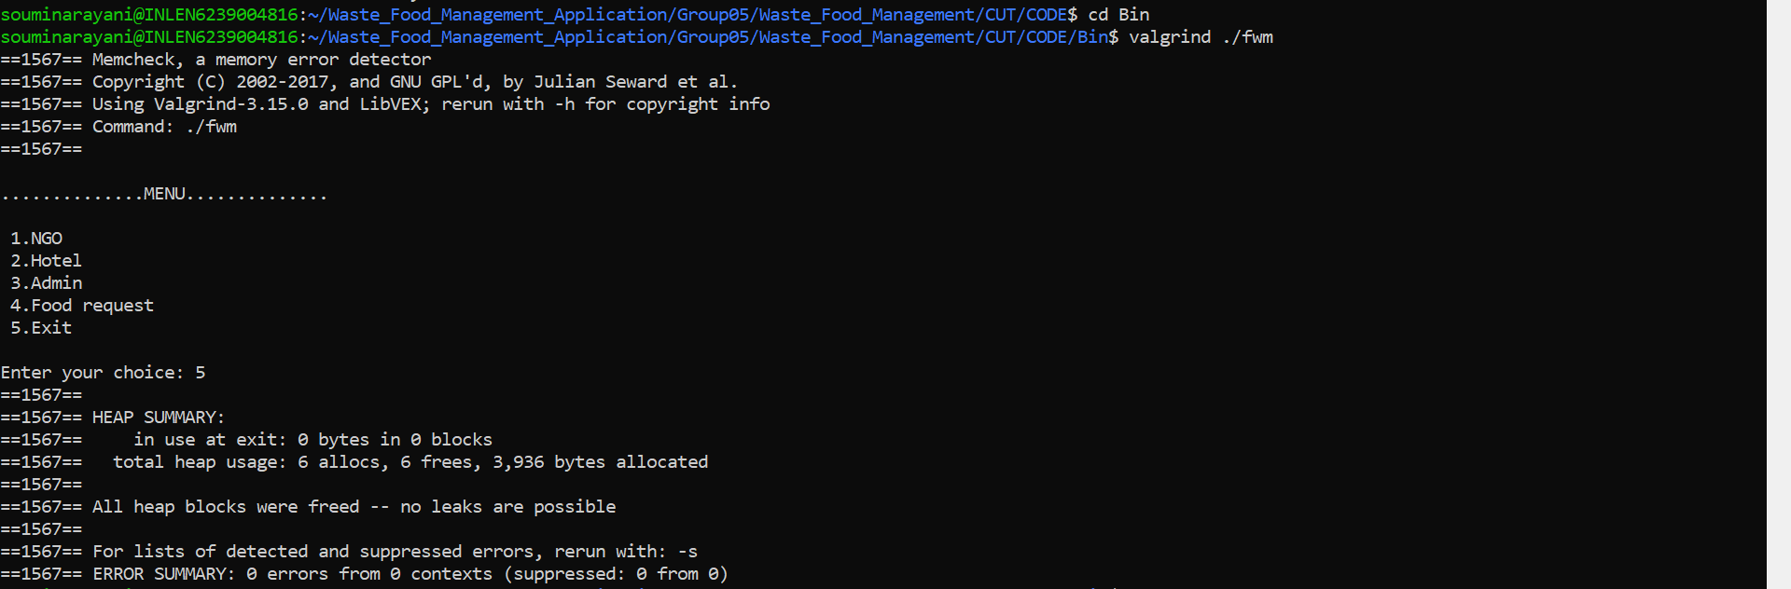

1. **Testing**

**6.1 : Unit Testing :**

UT_01 : NGO_Registration

UT_02 : NGO_Edit

UT_03 : NGO_View

**6.2 : Integrating Testing :**

IT_01 : NGO

IT_02 : Hotel

IT_03 : Admin

**7.Environment Description:**

**7.1 Time Zone Support:** IST- Kolkata

**7.2 Language Support:** English

**7.3 User Desktop Requirements:**

a. 64-bit processor, 1 GHz or faster

b. At least 2 GB free hard drive space

c. At least 1 GB RAM

**7.4 Server-Side Requirements:**

a. 64-bit processor, 1 GHz or faster

b. At least 1 GB free hard drive space

c. At least 1GB RAM

**7.4.1 Deployment Considerations:**

a. Easy setup: no session storage daemon, use tmpfs and memory

caching to enhance performance.

b. Local storage is used.

c. No network latency to consider.

d. To scale buys a bigger CPU, more memory, larger hard drive, or

additional hardware.

**7.4.2 Application Server Disk Space:**

No such disk space is required as the program is fully functional on

online IDE(s) as well. The Local Operating System is required and

one text file to store the records of processes.

**7.4.3 Database Server Disk Space:**

No such disk space is required as the program is fully functional on

online IDE(s) as well. The Local Operating System is required and

one text file to store the records of processes.

**7.4.4 Integration Requirements:**

1. Language: C

2. Tools: Splint , Valgrind

3. Complier: gcc

4. Linux Environment

**7.4.5 Jobs:**

We can establish connections between clients who are connected to the server. And we can search the chat history of the clients.

**7.4.6 Network:** End to End

**7.5 Configuration:**

**7.5.1: Operating System**: Linux environment